Bell Work
Monday 1/9/23
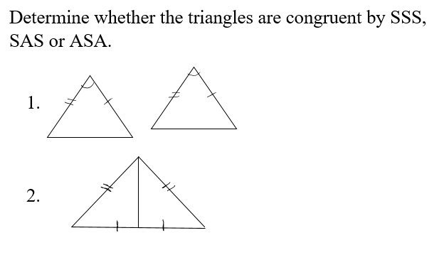

Bell Work
Tuesday 1/10/23

- Is it possible to have a triangle with one right angle, one obtuse angle and one acute angle? Explain

- Sketch and label right isosceles triangle ABC with right angle C.

Bell Work
Wednesday 1/11/23

- What is the sum of the exterior angles in a heptagon?

- What is the sum of the interior angles in a heptagon?

- What is the measure of each interior angle in a heptagon?

Bell Work
Thursday 1/12/23

- Find the measures of w, x, y, and z in the parallelogram.

- Explain how to solve for z in two different ways.

