Bell Work
Monday 10/03/22

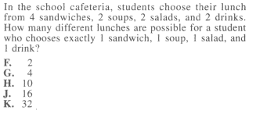
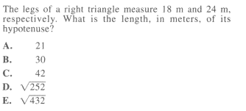
1. 2.

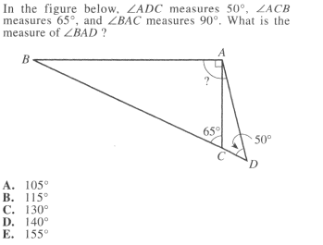
3.

Bell Work
Tuesday 10/04/22
ACT

Bell Work
Wednesday 10/05/22

Simplify the following radicals
- $\sqrt{160}$

- $2x\sqrt{80x^{5}}$

- 3$\sqrt{12}∙2\sqrt{32}$

