Bell Work
Monday 11/7/22

- We will be studying quadratics in the next unit (Unit 12). Using what you learned in units 2 and 11, give an example of a function, $f\left(x\right)$, that is a quadratic trinomial.

- $(3x-1)(4x+2)$

Bell Work
Tuesday 11/8/22

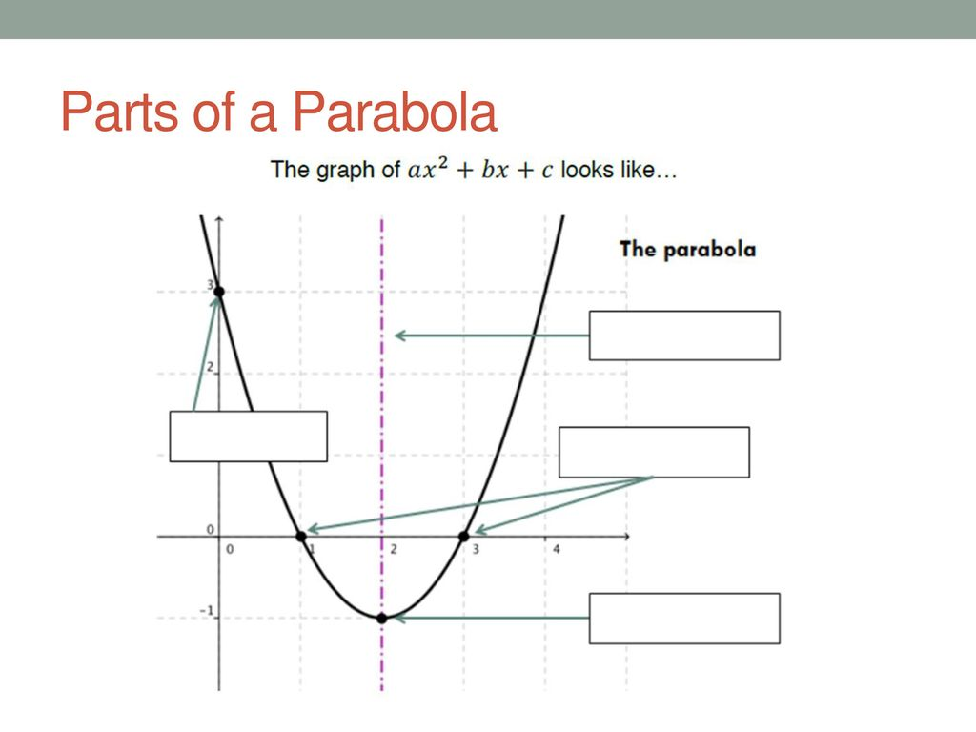
Label the parts of the parabola.
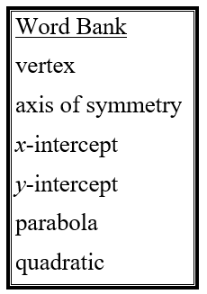

Bell Work
Wednesday 11/9/22

Graph the function $y=x^{2}+2x+5$

1. Identify a, b, & c.
2. Graph the axis of symmetry.
3. Find the vertex.
4. Plot the y-intercept and its reflection.
5. Draw the graph through the points. Label the points.

Bell Work
Thursday 11/10/22

- Suppose a rocket is launched from ground level. The equation $h=128t-16t^{2}$, represents the height of the rocket at time t. How long does it remain in the air?

