Bell Work
Monday 12/12/22

- Consider the graph of $y=-2x^{4}+8x^{3}-8x^{2}+2$ and determine the following:
a. Domain
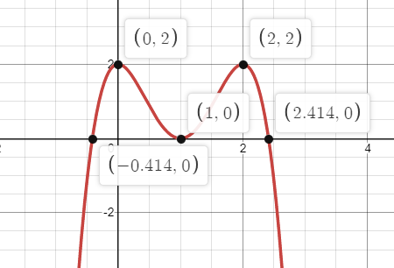
b. Range

c. y-intercept

Bell Work
Tuesday 12/13/22

- Consider the graph of $y=-2x^{4}+8x^{3}-8x^{2}+2$ and determine the following:
a. Real zeros
b. Relative maximum(s)

c. Relative minimum(s)

Bell Work
Wednesday 12/14/22

- Consider the graph of $y=-2x^{4}+8x^{3}-8x^{2}+2$ and determine the following:
a. Turning points
b. End behavior

c. The number of real and imaginary roots.

Bell Work
Thursday 12/15/22

1. Find all real solutions for $y=2x^{3}+8x^{2}+4x+16$
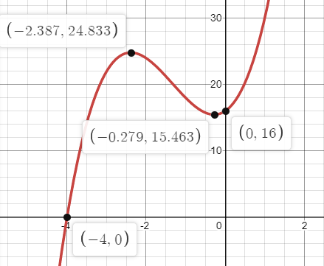

Bell Work
Monday 12/13/21

- Determine the domain and range for $y=-15x^{6}-6x^{3}-4x+1$
